# SOLUTION ARCHITECTURE

Team Lead 1: N.Bala Kumar

Team Member 2: K.M.Guruprasath

Therewasno an fficientsolutionavailableinthemanycompanies during these days. Every process was based on paperwork, human fault rate was high, the process and the tracing the inventory losses were not possible, and there were no efficient logging systems.

After the computer age, every process is started to be integrated t into electronic environment. And now we have qualified technology to implement new solutions to these problems.

* Example - Solution Architecture Diagram

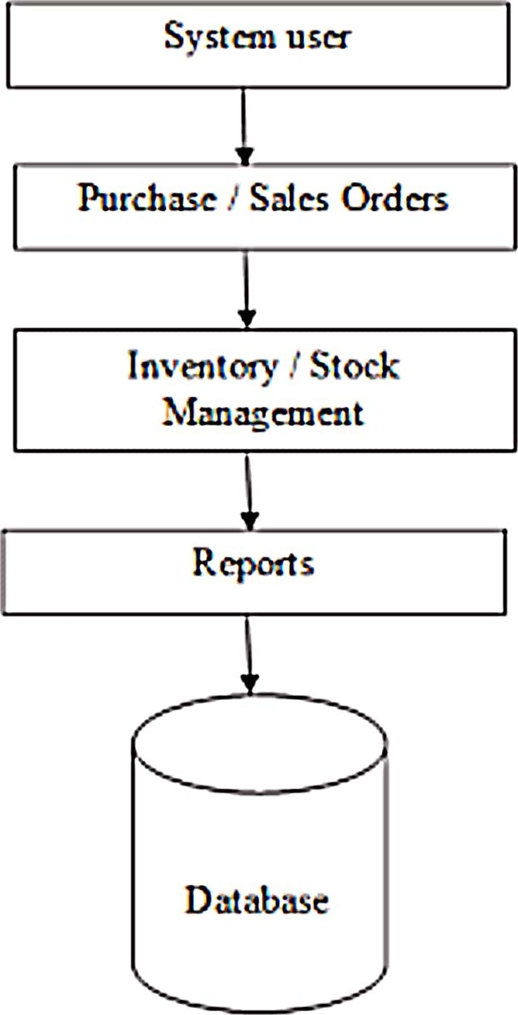

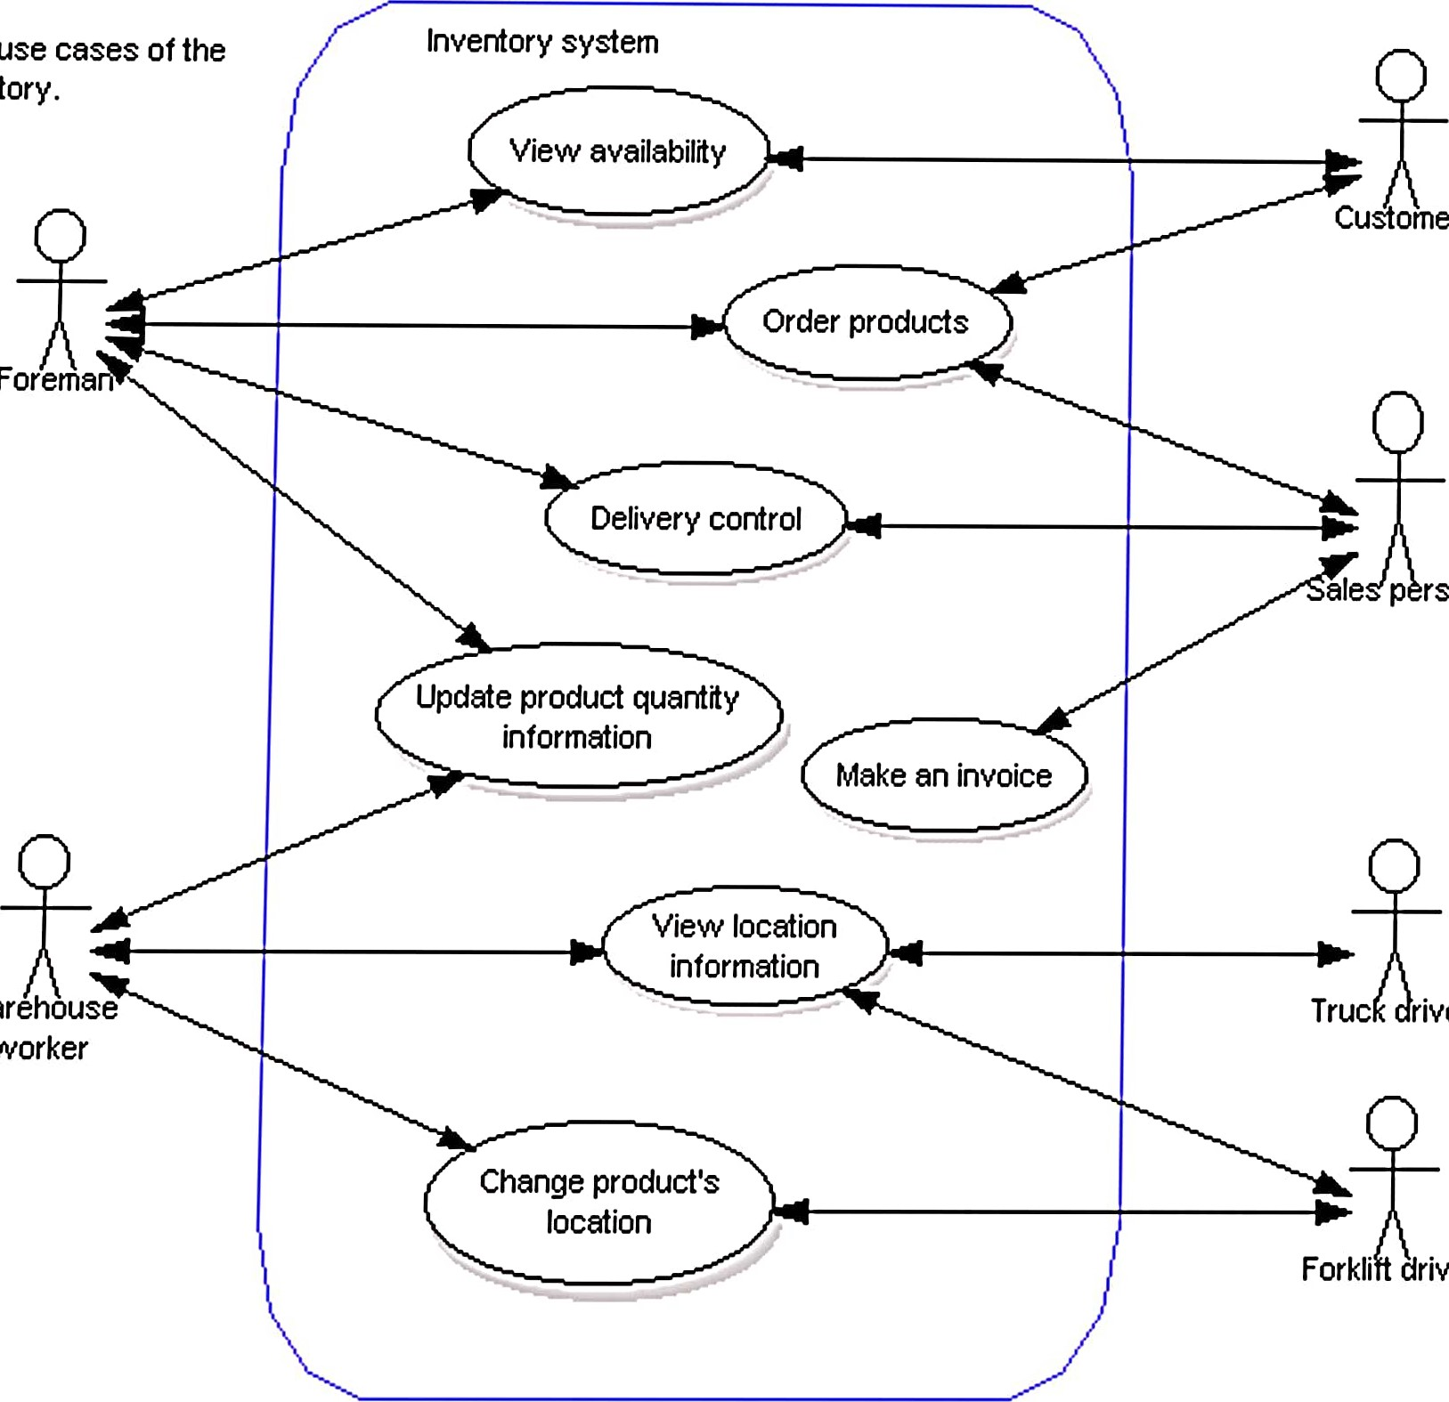

Customer

river

driver

Foreman»

Warehouse

worker

Main

inventory.

rson

control information